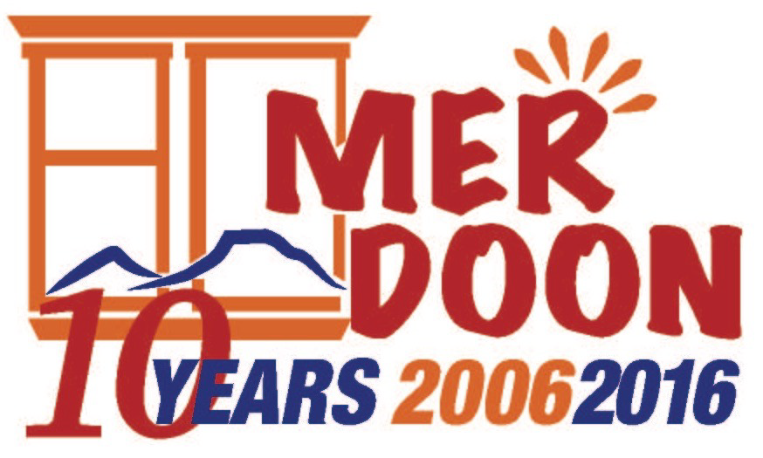

FOR IMMEDIATE RELEASE CONTACT: Beth Broussalian
July 8, 2016 (858) 248-2656
merdoonarmenia@gmail.com

BOHJALIAN AND ZANOYAN JOIN
MER DOON’S NEW ADVISORY BOARD
Mer Doon Forms Advisory Board in Honor of 10th Anniversary

Echmiadzin, Armenia – Internationally acclaimed and bestselling author, Chris Bohjalian, and global energy expert and author, Vahan Zanoyan, have joined Mer Doon’s new Advisory Board. Their role will be to impart strategic advice and non-financial support to the organization.

Chris Bohjalian is the author of 18 books, most of which were New York Times bestsellers. His work has been translated into over 30 languages and have been turned into movies three times. His books have been chosen as Best Books of the Year by the Washington Post, the St. Louis Post-Dispatch, the Hartford Courant, the Milwaukee Journal-Sentinel, Publishers Weekly, Library Journal, Kirkus Reviews, Bookpage, and Salon.

His awards include the ANCA Freedom Award for his work educating Americans about the Armenian Genocide; the ANCA Arts and Letters Award for The Sandcastle Girls, as well as the Saint Mesrob Mashdots Medal. His novel, Midwives, was a number one New York Times bestseller, a selection of Oprah's Book Club, and a New England Booksellers Association Discovery pick. He is a Fellow of the Vermont Academy of Arts and Sciences.

Chris lives in Vermont with his wife, the photographer Victoria Blewer. Their daughter, Grace Experience, is a young actor in New York City. Among the audiobooks she has narrated are Close Your Eyes, Hold Hands and The Guest Room.

Bohjalian shared, “I was so impressed by the young women I met at Mer Doon last year and so moved by their stories. These are smart, courageous, remarkable young people. And I was so honored to glimpse the incredible work of Mer Doon. It is a home, with all that word connotes, and it is changing lives in meaningful and important ways."

Vahan Zanoyan is an author, traveler and global energy expert. With over 35 years of experience, he served as the Chief Executive Officer of First Energy Bank, and President of PFC Energy International, a part of PFC Energy, Inc. Zanoyan serves as a consultant to numerous international and national oil companies, banks, and other private and public organizations throughout the United States, the Middle East, the Far East and Latin America. He has travelled extensively throughout the world in both his professional and personal life. Zanoyan has published two volumes of poetry.

Most notably, he published a debut novel in 2013, called A Place Far Away and its sequel, The Doves of Ohanavank in 2014, both of which tackle the horrifying activities of trans-national criminal organizations engaged in human and sex trafficking in Armenia and the Middle East. Zanoyan is widely regarded as one of few writers with extensive knowledge and understanding of trafficking. He currently divides his time between Southern California, Armenia and the Middle East.

Vahan stated, “Mer Doon is a formidable organization which performs a critical function in Armenia, by providing a nurturing home to young girls as they get dismissed from orphanages upon turning 18. My wife and I have visited Mer Doon in Etchmiadzin on several occasions, and love seeing the wonderful and talented residents there as often as we can.”

Stephen Ashekian, Chairman of Mer Doon, stated, “We are truly honored that Chris and Vahan have agreed to become Advisory Board members. I believe when great people encourage a great cause, it’s a win-win for everyone.”

Many corporate, organizational, and individual supporters help advance Mer Doon’s mission. Mer Doon’s corporate and organizational partners include U.S. Embassy Women’s Mentoring Program, Embassy of Lithuania, Microsoft Armenia, Megerian Carpet, Fund for Armenian Relief (FAR), Society for Orphaned Armenian Relief (SOAR), Echmiadzin Municipality, Gavar Orphanage, Vanadzor Orphanage, Armenia Tree Project, Armenian Eyecare Project, SOS Children’s Village, and St. John Armenian Church – Detroit Women’s Guild.

Mer Doon provides orphaned and disadvantaged young women (ages 18-24) a loving and nurturing place to call “home.” Our mission is to educate and empower them with skills to live independently in mainstream society. The organization’s Co-Founder and Executive Director, Tigranuhi Karapetyan, manages the daily operations of the program.

Mer Doon is located in Echmiadzin, Armenia. It is a registered 501(c)(3) nonprofit organization in the State of Connecticut and a nongovernmental organization registered in the Republic of Armenia. It has no political or religious affiliations. Tax-deductible donations can be made by going to www.mer-doon.com and clicking on “Donate”. For information, please email www.mer-doon.com. Visitors are always welcome!

