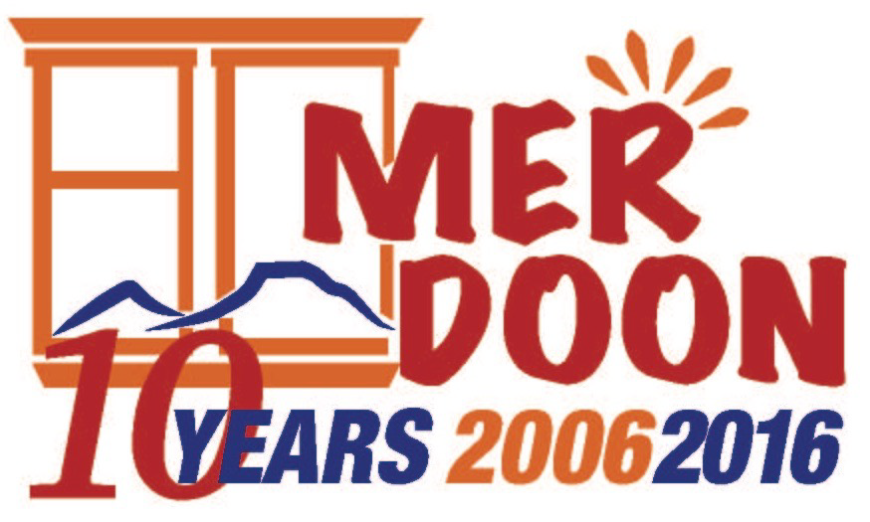

FOR IMMEDIATE RELEASE CONTACT: Beth Broussalian
September 13, 2016 (858) 248-2656
merdoonarmenia@gmail.com

MER DOON LAUNCHES CROWD FUNDING
CAMPAIGN TO PURCHASE USED VAN
Campaign Created to Raise $5,000

Echmiadzin, Armenia – Mer Doon has launched a crowd funding campaign on Crowdrise to raise the $5,000 needed to reach Mer Doon’s goal of $15,000 to purchase a much needed used van. An anonymous supporter from California has generously donated the first $10,000. This year the organization is celebrating its 10th anniversary, and it has never owned a vehicle. Mer Doon’s staff and girls have been obliged to use buses and taxis for all their transportation needs.

To give to the campaign, donors are asked to visit the Crowdrise page at https://www.crowdrise.com/help-mer-doon.

The van will be used to transport Mer Doon’s residents to and from their college and university classes, internships and jobs, vocational training, and community activities. In addition, the van will allow the girls to make pilgrimages to the ancient, religious sites throughout Armenia and Artsakh. A van will also be useful to staff for errands, procuring food and supplies, and meetings in Yerevan.

Stephen Ashekian, chairman of Mer Doon, stated, “We sat down with our staff earlier in the year and asked them what their most critical needs were. They unanimously said that the organization desperately needs a van to carry out its mission. We are grateful to have already received 2/3 of the total amount needed, and hope the crowd funding campaign will help us reach our goal. We hope to have a van parked outside of Mer Doon by the end of this year.”

Ashekian also noted that corporate sponsorships are available. A company wishing to donate the full amount of $5,000 will receive significant sponsorship benefits, including the company’s logo on the outside of the van, an official unveiling with local media coverage, a clickable logo link on Mer Doon’s website, a clickable logo link in Mer Doon’s eblasts, a press release announcing the sponsorship, an eblast announcement to Mer Doon’s database, the company’s logo in printed marketing, and a pomegranate plaque on our giving tree in our Garden of Angels.

Mer Doon’s mission is championed by many corporate, organizational, and individual supporters. Mer Doon’s corporate and organizational partners include U.S. Embassy Women’s Mentoring Program, Embassy of Lithuania, Microsoft Armenia, Megerian Rugs & Carpet, Fund for Armenian Relief (FAR), Society for Orphaned Armenian Relief (SOAR), Echmiadzin Municipality, Gavar Orphanage, Vanadzor Orphanage, Armenia Tree Project, Armenian Eyecare Project (AECP), SOS Children’s Village, and St. John Armenian Church–Detroit Women’s Guild.

Mer Doon provides orphaned and disadvantaged young women (ages 18-24) a loving and nurturing place to call “home.” Our mission is to educate and empower girls with skills to live independently in mainstream society. The organization’s Co-Founder and Executive Director, Tigranuhi Karapetyan, manages the daily operations of the program.

Mer Doon is located in Echmiadzin, Armenia. It is a registered 501(c)(3) nonprofit organization in the State of Connecticut and a nongovernmental organization registered in the Republic of Armenia. It has no political or religious affiliations. Tax-deductible donations can be made by going to www.mer-doon.com and clicking on “Donate”. For information, please email www.mer-doon.com. Visitors are always welcome!

###

